**Manufacturing thrill for ITER magnetic rings**

[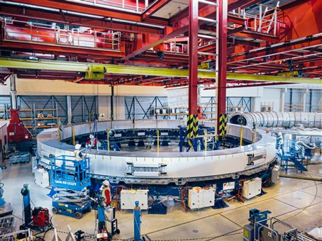](https://f4e.europa.eu/Downloads/News/12_PF_web_2_04122019-041220191200-Large.jpg)

Poloidal Field coil 5 positioned to the impregnation table, in the PF coils factory on-site, where four of the five coils that Europe is responsible for will be manufactured. F4E has financed this facility. November 2019, Cadarache, France © F4E

​The factory on the ITER site where Europe is manufacturing four of its Poloidal Field (PF) coils is full of equipment. The 250 m hall is filled up with work stations and tooling, positioned in the order of the various manufacturing steps, operated by nearly 50 technicians and operators. Winding tables, stacking stations, impregnation tooling and cryostats are occupying the space. Above them, powerful cranes move across the hall lifting the heavy components. The teams of ASG Superconductors, CNIM and the representatives of F4E have just concluded a meeting assessing the state of play. The news is good. Two coils – PF5 and PF2 – are shaping up nicely, entering the final stages of production.

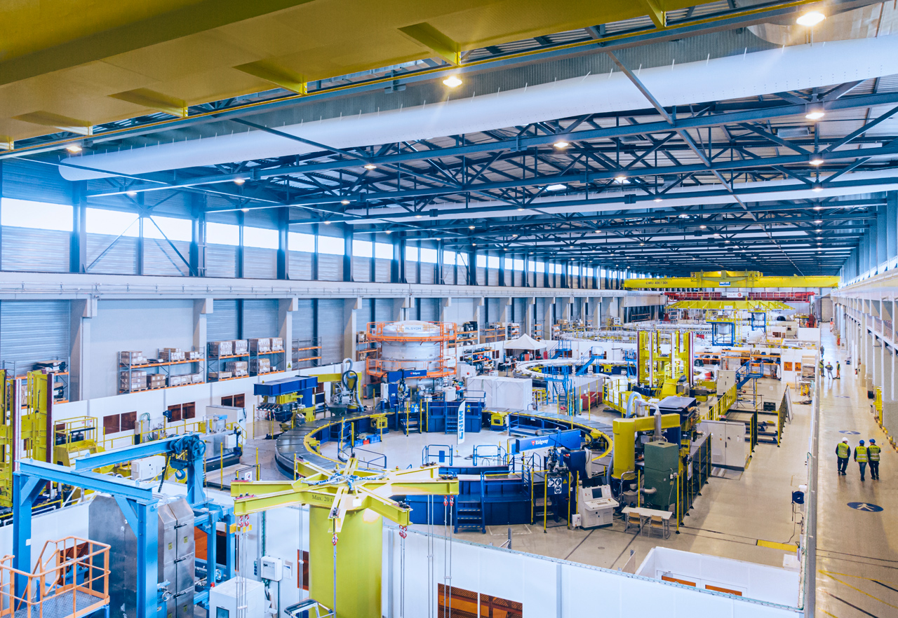

View of ITER Poloidal Field coils factory on-site, where four of the five coils that Europe is responsible for will be manufactured. F4E has financed this facility. November 2019, Cadarache, France © F4E

Both coils have gone through a total transformation.  The days where the workforces were winding lengths of conductor are gone. They have been insulated, and become flat spiral coils known as Double Pancakes (DPs). The DPs of PF5 have been stacked and they have been wrapped as one. Now the coil is in its impregnation phase. While it rests in a thin metallic mould, fluid resin will be injected to harden the component. Early in 2020, the coil will go through the stage of finishing works and will be cryotested.  When works will be completed this coil will weigh roughly 342 t. A few metres away, another impressive component is going through a similar fabrication process. The six DPs that form PF2 have been wound and four of them have been successfully impregnated. By early spring in 2020, it is expected that the remaining two will also be fully impregnated. And by the time this component is ready to be cryotested, the third and fourth PF coils will start occupying the work stations.

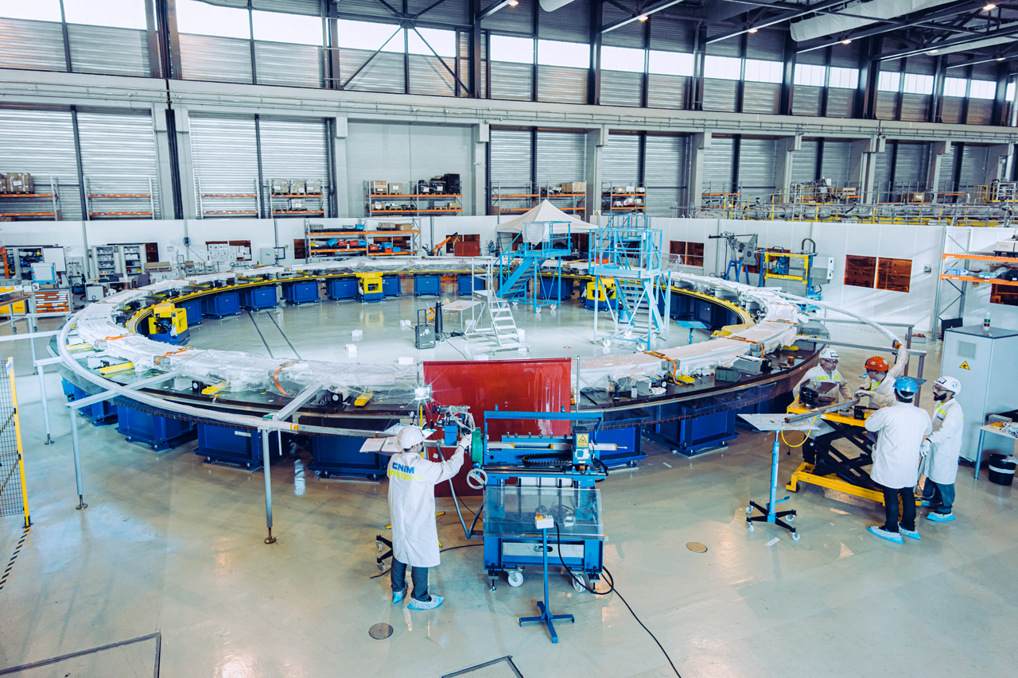

CNIM technicians working at the Termination station in the PF coils factory on-site, where four of the five coils that Europe is responsible for will be manufactured. F4E has financed this facility. November 2019, Cadarache, France © F4E

Pierluigi Valente, F4E's Technical Responsible Officer following the manufacturing of the PF coils from the very start, comments on the evolution of the components. "I recall when the winding operations started, during which we had to learn how to work as one team, and to become familiar with the tooling. The number of people involved has gradually increased and in parallel, we mastered the fabrication techniques. Now we have solid know-how and this also explains why the speed of production has accelerated," he says. Thierry Boutboul, having the overview of the European PF coils, highlights how some aspects of the improvement plan. "We revised our working method, improved the training of personnel, and restructured the work between various parties to meet our tight deadlines. We are already installing an additional crane and will erect an annex to carry out the demolding process and some of the manufacturing steps of PF3 and PF4," he explains.

The arrival of PF6, the completion of PF5 and PF2, together with the winding tooling preparation for PF4 and PF3 will covert this factory on-site as one of the busiest ITER facilities in the year to come.